Ch 15 Programming - Dynamic Programming
CS3000
Rebekah Jensen

BreakingAString
I started with my base case: if no cuts need to be made, they cost nothing (0). Then I sorted the cuts to organize them in a bottom-up fashion (dynamic programming, yay!). Next I created my dynamic programming table to store the min cost for cutting between my breaks and stored the order in my order variable. Next, I filled up the dp table with the lengths, starting with the smaller ones first. I did this comparing the left and right segments of the strings and used it to compute the costs. I then sorted the order of cuts starting from the minimum cost. Lastly, I returned the min cost for the string and the order of the cuts.
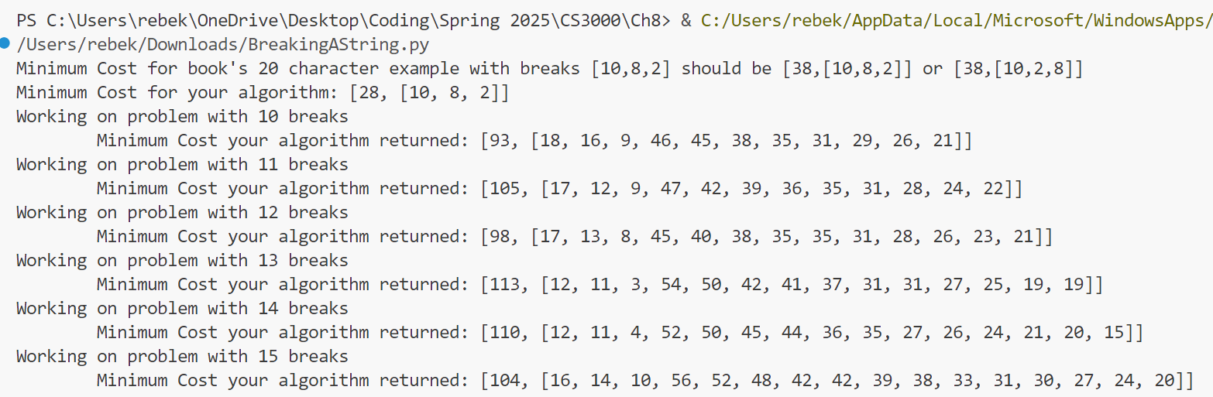
Results
It printed for a while (and must faster!) once I added the dynamic programming portion. As you can see, it printed the desired results from Dr. B’s tester.

Palindrome
This one was pretty easy to add the dynamic programming. We did some palindrome work in Intro to Algorithms and Data Structures, so it was fun to see it come back.
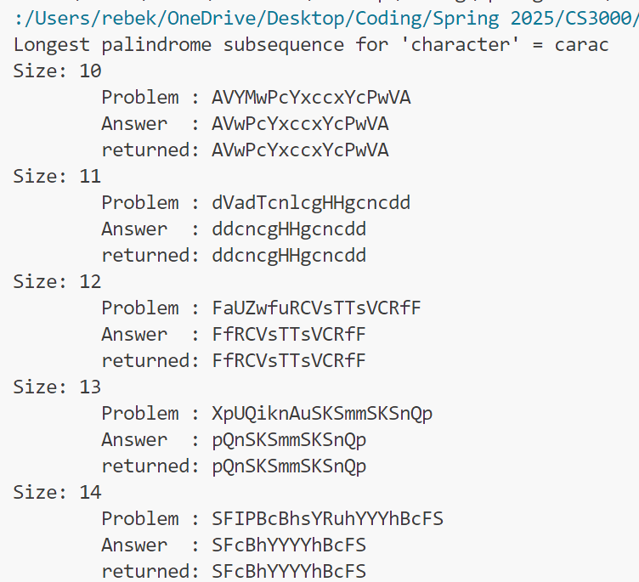
To start, I added an empty memoization table to store my strings and make sure I don’t try to compute them multiple times. Next, to check my base case, I checked if the string was empty or held one character, which would automatically make it a palindrome. Then I added an if statement that checks if I’d already computed the string, if yes, then I return the already stored result so it doesn’t get re-done. Next, I checked my characters to see if my string is a palindrome. I did this be slowly checking each character, from first to last to see if they match. If they didn’t, then I took the longer of my results and ignored what I had found. Finally, I stored my results in my memo table and called my main utilize function to run it.

Results
This is what printed after running my code with the tests Dr. B provided. As you can see, it all works as it should.

